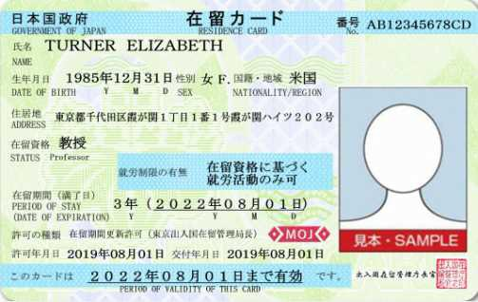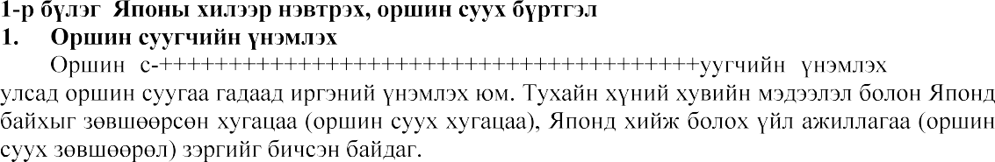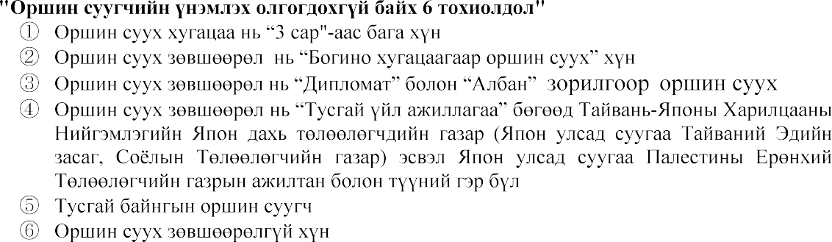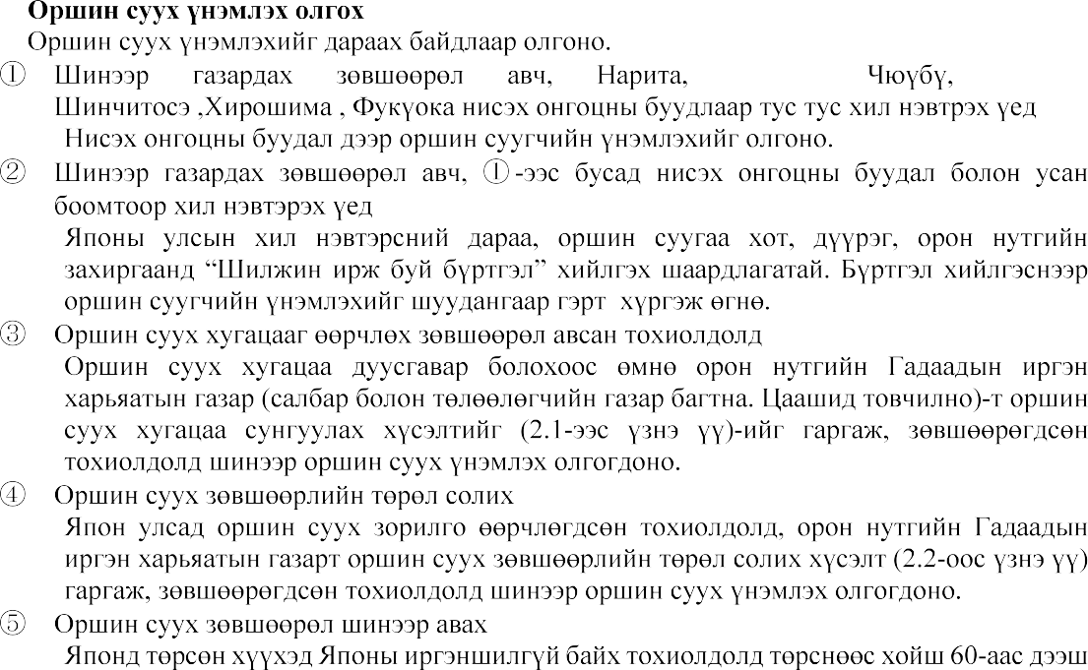

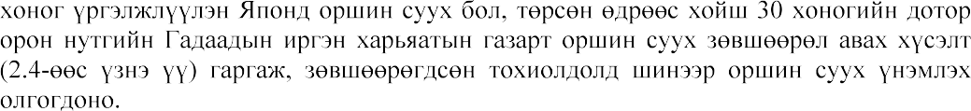

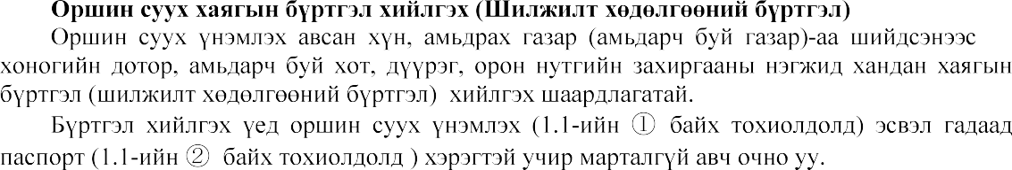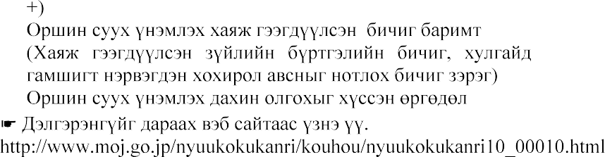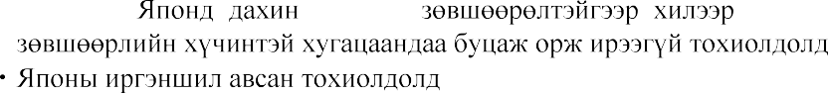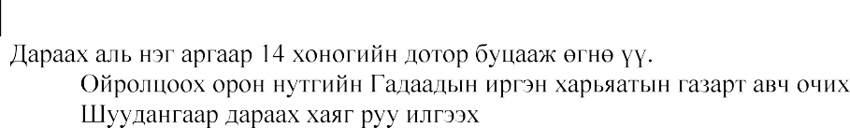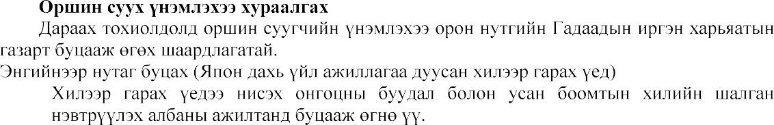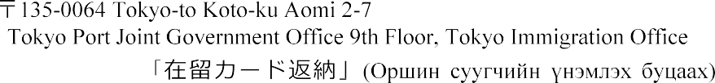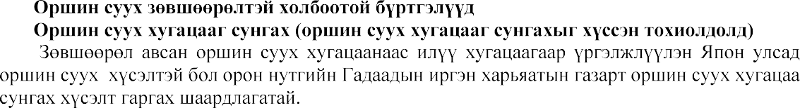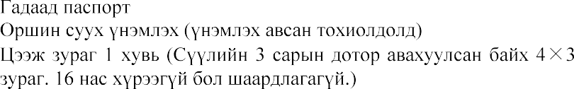

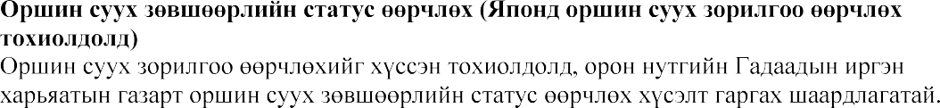

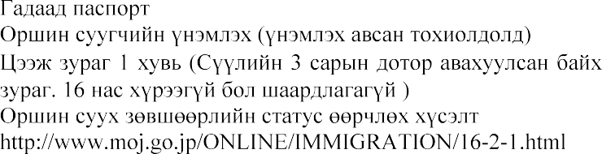

[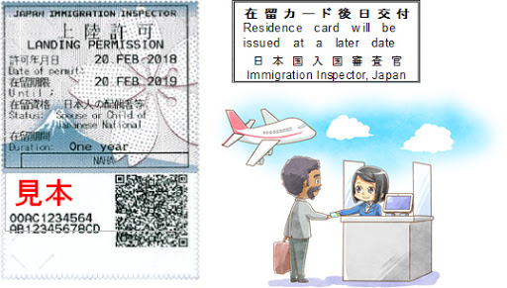](https://www.google.co.jp/url?sa=i&url=http://www.immi-moj.go.jp/newimmiact_4/port-city.html&psig=AOvVaw0gyBsd4nVBNpNHMOCqjdEn&ust=1601532784393000&source=images&cd=vfe&ved=0CAIQjRxqFwoTCLiOqeKckOwCFQAAAAAdAAAAABAE)